**Chapter 5**

**Introduction to IP Address**

IP address is an address having information about how to reach a specific host, especially outside the LAN. An IP address is a 32 bit unique address having an address space of 232.  
Generally, there are two notations in which IP address is written, dotted decimal notation and hexadecimal notation.

Dotted Decimal Notation:

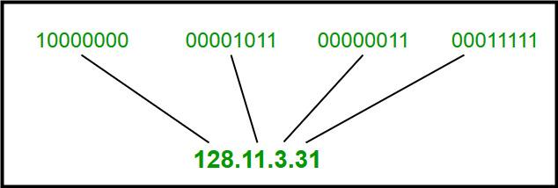

Hexadecimal Notation:

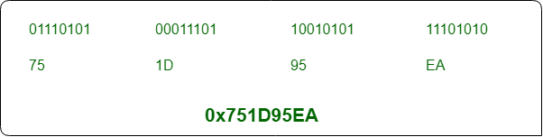

Some points to be noted about dotted decimal notation:

1. The value of any segment (byte) is between 0 and 255 (both included).
2. There are no zeroes preceding the value in any segment (054 is wrong, 54 is correct).

Classful Addressing  
The 32 bit IP address is divided into five sub-classes. These are:

* Class A
* Class B
* Class C
* Class D
* Class E

Each of these classes has a valid range of IP addresses. Classes D and E are reserved for multicast and experimental purposes respectively. The order of bits in the first octet determine the classes of IP address.  
IPv4 address is divided into two parts:

* Network ID
* Host ID

The class of IP address is used to determine the bits used for network ID and host ID and the number of total networks and hosts possible in that particular class. Each ISP or network administrator assigns IP address to each device that is connected to its network.

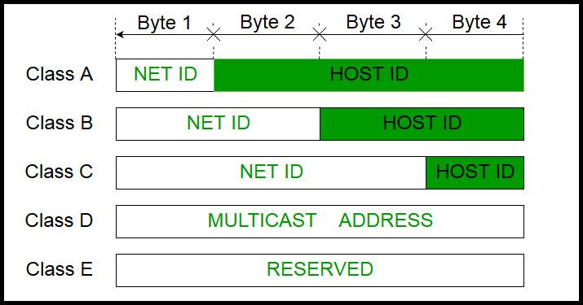

Note: IP addresses are globally managed by Internet Assigned Numbers Authority(IANA) and regional Internet registries(RIR).

Note: While finding the total number of host IP addresses, 2 IP addresses are not counted and are therefore, decreased from the total count because the first IP address of any network is the network number and whereas the last IP address is reserved for broadcast IP.

Class A:

IP address belonging to class A are assigned to the networks that contain a large number of hosts.

* The network ID is 8 bits long.
* The host ID is 24 bits long.

The higher order bit of the first octet in class A is always set to 0. The remaining 7 bits in first octet are used to determine network ID. The 24 bits of host ID are used to determine the host in any network. The default subnet mask for class A is 255.x.x.x. Therefore, class A has a total of:

* 2^7-2= 126 network ID(Here 2 address is subracted because 0.0.0.0 and 127.x.y.z are special address. )
* 2^24 – 2 = 16,777,214 host ID

IP addresses belonging to class A ranges from 1.x.x.x – 126.x.x.x  
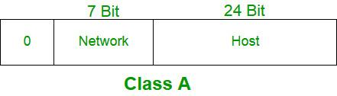

Class B:

IP address belonging to class B are assigned to the networks that ranges from medium-sized to large-sized networks.

* The network ID is 16 bits long.
* The host ID is 16 bits long.

The higher order bits of the first octet of IP addresses of class B are always set to 10. The remaining 14 bits are used to determine network ID. The 16 bits of host ID is used to determine the host in any network. The default sub-net mask for class B is 255.255.x.x. Class B has a total of:

* 2^14 = 16384 network address
* 2^16 – 2 = 65534 host address

IP addresses belonging to class B ranges from 128.0.x.x – 191.255.x.x.  
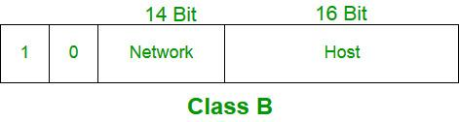

Class C:

IP address belonging to class C are assigned to small-sized networks.

* + The network ID is 24 bits long.
  + The host ID is 8 bits long.

The higher order bits of the first octet of IP addresses of class C are always set to 110. The remaining 21 bits are used to determine network ID. The 8 bits of host ID is used to determine the host in any network. The default sub-net mask for class C is 255.255.255.x. Class C has a total of:

* + 2^21 = 2097152 network address
  + 2^8 – 2 = 254 host address

IP addresses belonging to class C ranges from 192.0.0.x – 223.255.255.x.  
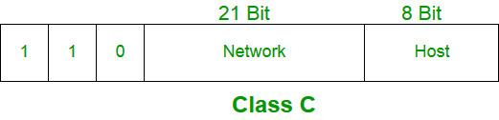

Class D:

IP address belonging to class D are reserved for multi-casting. The higher order bits of the first octet of IP addresses belonging to class D are always set to 1110. The remaining bits are for the address that interested hosts recognize.

Class D does not posses any sub-net mask. IP addresses belonging to class D ranges from 224.0.0.0 – 239.255.255.255.  
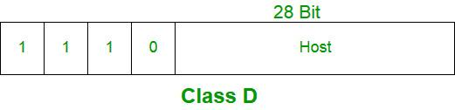

Class E:

IP addresses belonging to class E are reserved for experimental and research purposes. IP addresses of class E ranges from 240.0.0.0 – 255.255.255.254. This class doesn’t have any sub-net mask. The higher order bits of first octet of class E are always set to 1111.  
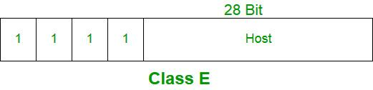

Range of special IP addresses:

169.254.0.0 – 169.254.0.16 : Link local addresses  
127.0.0.0 – 127.0.0.8 : Loop-back addresses  
0.0.0.0 – 0.0.0.8 : used to communicate within the current network.

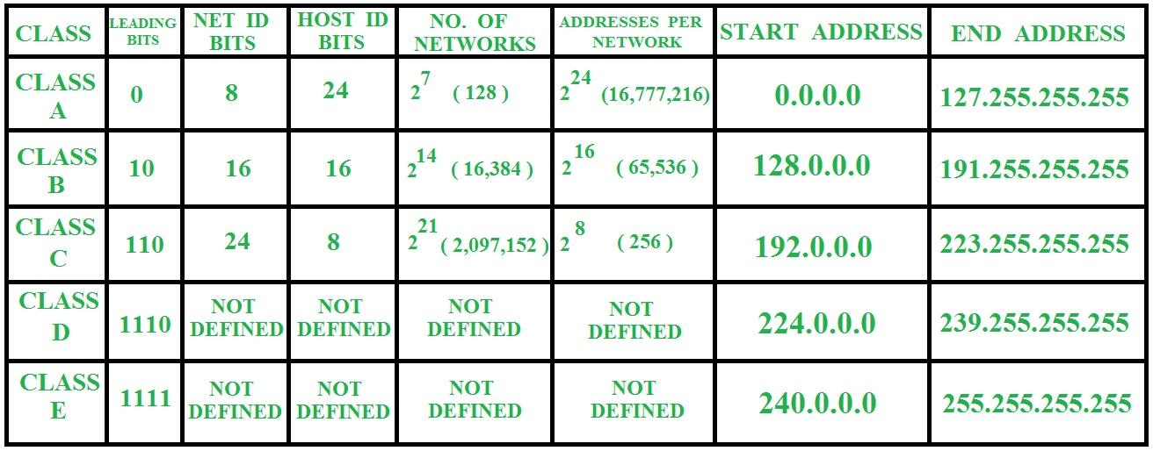

**Introduction To Subnetting and class C Subnetting**

When a bigger network is divided into smaller networks, in order to maintain security, then that is known as Subnetting. so, maintenance is easier for smaller networks.

Now, let’s talk about dividing a network into two parts:  
so to divide a network into two parts, you need to choose one bit for each Subnet from the host ID part.

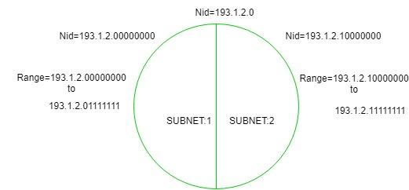

In the above diagram, there are two Subnets.

Note: It is a class C IP so, there are 24 bits in the network id part and 8 bits in the host id part.

* For Subnet-1:  
  The first bit which is chosen from the host id part is zero and the range will be from (193.1.2.00000000 till you get all 1’s in the host ID part i.e, 193.1.2.01111111) except for the first bit which is chosen zero for subnet id part.

Thus, the range of subnet-1:

193.1.2.0 to 193.1.2.127

* For Subnet-2:  
  The first bit chosen from the host id part is one and the range will be from (193.1.2.100000000 till you get all 1’s in the host ID part i.e, 193.1.2.11111111).

Thus, the range of subnet-2:

193.1.2.128 to 193.1.2.255

Note:

1. To divide a network into four (22) parts you need to choose two bits from host id part for each subnet i.e, (00, 01, 10, 11).
2. To divide a network into eight (23) parts you need to choose three bits from host id part for each subnet i.e, (000, 001, 010, 011, 100, 101, 110, 111) and so on.

**Classless Addressing**

* Classless Addressing is an improved IP Addressing system.
* It makes the allocation of IP Addresses more efficient.
* It replaces the older classful addressing system based on classes.
* It is also known as Classless Inter Domain Routing (CIDR).

CIDR IP Addresses look like-

a.b.c.d / n

 They end with a slash followed by a number called as IP network prefix.

* IP network prefix tells the number of bits used for the identification of network.
* Remaining bits are used for the identification of hosts in the network.

Example-

 An example of CIDR IP Address is-

182.0.1.2 / 28

It suggests-

* 28 bits are used for the identification of network.
* Remaining 4 bits are used for the identification of hosts in the network.

Another Example

Given CIDR representation is 20.10.30.35 / 27.

 It suggests-

* 27 bits are used for the identification of network.
* Remaining 5 bits are used for the identification of hosts in the network.

Given CIDR IP Address may be represented as-

00010100.00001010.00011110.00100011 / 27

 So,

* First IP Address = 00010100.00001010.00011110.00100000 = 20.10.30.32
* Last IP Address = 00010100.00001010.00011110.00111111 = 20.10.30.63

Thus, Range of IP Addresses = [ 20.10.30.32 , 20.10.30.63]

**IPV6 Address structure**

An IPv6 address is a 128-bit [alphanumeric](https://whatis.techtarget.com/definition/alphanumeric-alphameric) string that identifies an endpoint device in the Internet Protocol Version 6 ([IPv6](https://searchnetworking.techtarget.com/definition/IPv6-Internet-Protocol-Version-6)) addressing scheme.

It has been a concern for some time that the [IPv4](https://searchwindevelopment.techtarget.com/definition/IP-address) addressing scheme was running out of potential addresses. The IPv6 format was created to enable the trillions of new IP addresses required to connect not only an ever-greater number of computing devices but also the rapidly expanding numbers of items with embedded connectivity.

Address Structure

An IPv6 address is made of 128 bits divided into eight 16-bits blocks. Each block is then converted into 4-digit Hexadecimal numbers separated by colon symbols.

For example, given below is a 128 bit IPv6 address represented in binary format and divided into eight 16-bits blocks:

0010000000000001 0000000000000000 0011001000111000 1101111111100001 0000000001100011 0000000000000000 0000000000000000 1111111011111011

Each block is then converted into Hexadecimal and separated by ‘:’ symbol:

2001:0000:3238:DFE1:0063:0000:0000:FEFB

Even after converting into Hexadecimal format, IPv6 address remains long. IPv6 provides some rules to shorten the address. The rules are as follows:

Rule.1: Discard leading Zero(es):

In Block 5, 0063, the leading two 0s can be omitted, such as (5th block):

2001:0000:3238:DFE1:63:0000:0000:FEFB

Rule.2: If two of more blocks contain consecutive zeroes, omit them all and replace with double colon sign ::, such as (6th and 7th block):

2001:0000:3238:DFE1:63::FEFB

Consecutive blocks of zeroes can be replaced only once by :: so if there are still blocks of zeroes in the address, they can be shrunk down to a single zero, such as (2nd block):

2001:0:3238:DFE1:63::FEFB

Address Space

The length of an IPv6 address is 128 bits, compared with 32 bits in IPv4. The address space therefore has 2128 or approximately 3.4×1038 addresses , which is approximately 340 undecillion, or 340 billion billion billion billion, addresses.